IDENTIFICATION OF FACTORS CONTRIBUTING TO CHURN AND RETENTION

Contract Type
Contract type was a major factor influencing customer churn. Customers on month-to-month contracts showed higher churn behaviour compared to customers on fixed-term contracts. The absence of long-term commitment allows customers greater flexibility to discontinue their service, making them more sensitive to pricing changes, service experience, or competing offers.
Figure 1: Churn by contract
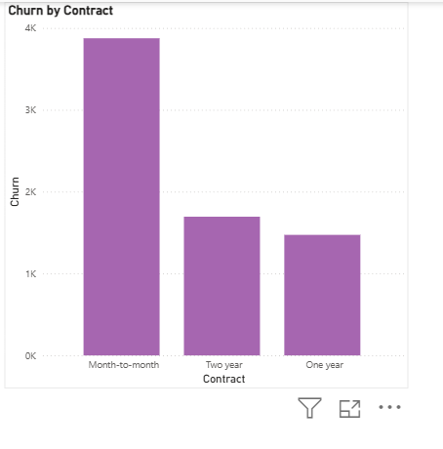
Figure1: Shows the month-to-month contractors are the highest churners
Customer segmentation showed that customer groups associated with flexible contract arrangements experienced higher churn levels compared to customers characterised by contract stability. In contrast, customers on longer-term contracts demonstrated stronger retention and more stable service continuity.
The ANN model’s strong churn detection performance confirms that contract type formed part of the predictive pattern used to identify customers at risk. This indicates that contract structure plays an important role in influencing whether customers remain or leave.

Customer Tenure
Customer tenure was another key factor influencing churn risk. Customers with shorter service duration were more likely to churn compared to customers with longer service relationships. This reflects the early stage of the customer lifecycle, where customers are still evaluating the service and are more likely to leave if their expectations are not fully met.
Customer segments associated with stronger retention demonstrated lower churn levels and were characterised by more established service relationships. In contrast, customers in higher-risk segments showed weaker relationship stability.
The ANN model successfully identified the majority of churn customers, confirming that tenure was an important characteristic influencing churn probability. This indicates that customer retention strengthens over time as the customer relationship becomes more established.

Monthly Charges
Monthly charges were strongly associated with churn behaviour. The customer segment with the highest churn rate of 41.62% was characterised by higher monthly charges, which was significantly above the overall churn rate of 26.5%.
This indicates that customers paying higher service costs were more likely to discontinue their service. Higher billing levels increase customer expectations of value, and when customers do not perceive sufficient benefit relative to cost, churn becomes more likely.
The ANN model’s predictive performance confirms that billing level was one of the factors influencing churn risk. Customers with higher monthly charges were more frequently classified as churn risk compared to lower-billing customers.

Customer Segments
Customer churn was not evenly distributed across the customer base but was concentrated within specific customer segments. Certain customer groups demonstrated significantly higher churn behaviour, while others showed stronger retention.
These differences reflect variations in customer characteristics such as contract structure, billing level, and relationship stability. The high-risk customer segment recorded substantially higher churn behaviour compared to other segments, confirming that customer profile plays an important role in retention outcomes.
The ANN model’s strong classification performance, including a ROC AUC score of 0.81, confirms that these segment differences were meaningful predictors of churn risk. This demonstrates that churn behaviour follows identifiable patterns linked to customer characteristics.

